# **User Manual: TaskMaster Application**

## **Running the Application**

Before using the TaskMaster application, ensure that you have Node.js and MySQL Workbench installed on your system. Follow the steps below to set up the environment:

* Install Dependencies in General Project Folder:
  + Open a terminal in the general project folder.
  + Run the following command to install dependencies:

npm install react cors mysql2 node express body-parser react-bootstrap

* Database Setup in MySQL Workbench:
  + Open MySQL Workbench on port 3001.
  + Create a database named taskmaster.
  + Inside the taskmaster database, create a table named tasks with the required schema.

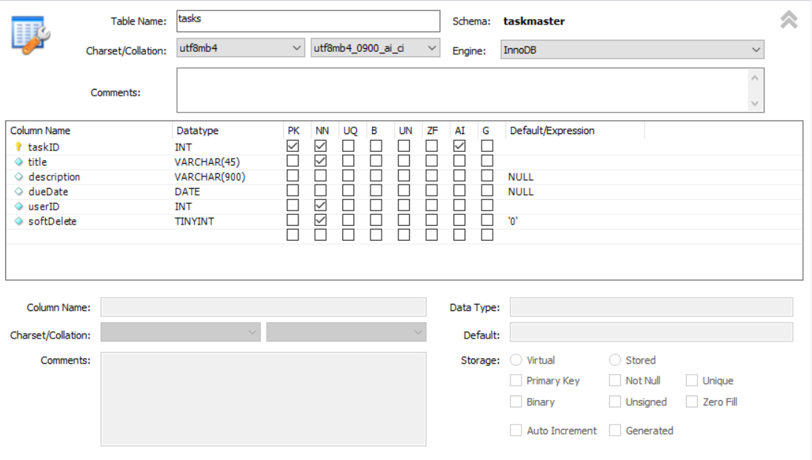

* + Additionally, create a table named users in the same schema.

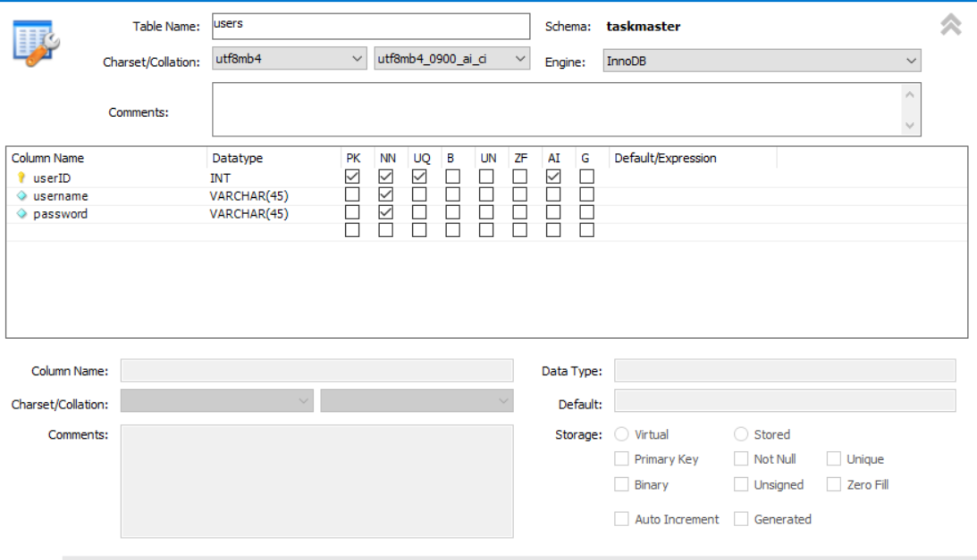

* Install Dependencies in SERVER Folder:
  + Navigate to the SERVER folder using the terminal.
  + Run the following command to install server dependencies:

npm install mysql2 express body-parser

* Start the Server:
  + In the SERVER folder, run the following command to start the server:

npm start

* Start the Application:
  + In the general project folder, run the following command to start the application:

npm start

## **Login**

* Enter Credentials:
  + Start the application and enter your username and password.
* Create Account:
  + If you don't have an account, click on "Create Account" and follow the prompts.
* Login:
  + After entering credentials, click on the "Login" button to access the TaskMaster application.

## **Creating Tasks**

* New Task:
  + Click on "New Task" in the top right corner of the screen.
* Fill Task Details:
  + Fill out all required fields for the task.
  + Note: Incomplete fields will prevent task creation, and the modal will not close.
* Save Task:
  + Click "Save Task" to create the task.

## **Viewing Task Description**

* Task Selection:
  + Click on the task you want to view the description of.

## **Editing a Task**

* Edit Task:
  + Click the "Edit" button of the task you want to edit.
* Modify Task:
  + Change the desired fields.
* Save Changes:
  + Click "Save Changes" to update the task.

## **Removing Tasks**

* Finish Task:
  + Click "Finish" on the task you want to remove.
  + Note: Tasks are soft deleted and remain in the database but won't be displayed on the web page.

Congratulations! You have successfully set up and navigated the TaskMaster application. If you encounter any issues, refer to this user manual or contact our support team for assistance.